NEURAL NETWORKS AND DEEP LEARNING

ASSIGNMENT 1

NAME: SRAVANI MANNURU

STUDENT ID: 700766162

GITHUB LINK: https://github.com/sravs2031/NEURAL-NETWORKS-DEEP-LEARNING-ASSIGNMENT-1.git

VIDEO LINK: https://drive.google.com/file/d/1m0mUt2J__m37FGZetEYQof4oWURD5y2t/view?usp=drive_link

1)

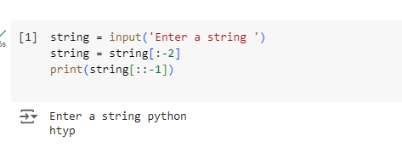

2)

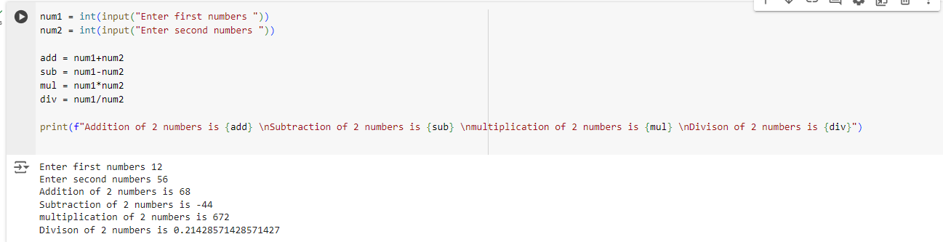

3)

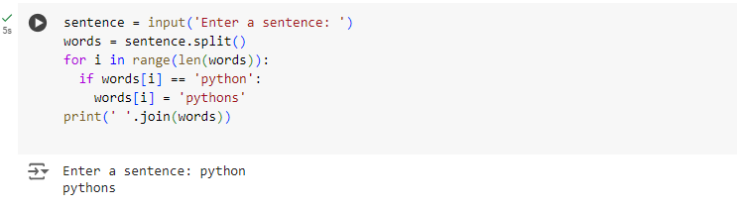

4)

